CONFIDENTIAL CS/OCT 2026/MAT133

UNIVERSITI TEKNOLOGI MARA FINAL EXAMINATION

COURSE
COURSE CODE
EXAMINATION TIME
PRE CALCULUS
MAT133 OCTOBER 2026
2 HOURS

INSTRUCTIONS TO CANDIDATES

- This question paper consists of 5 questions.

- Answer ALL questions in the Answer Booklet. Start each answer on a new page.

- Do not bring any material into the examination room unless permission is given by the invigilator .
- Please check to make sure that this examination pack consists of: i) the Question Paper
  - a one - page Append ix 1
  - an Answer Booklet - provided by the Faculty
  - a graph paper - provided by the Faculty

- Answer ALL questions in English.

/

DO NOT TURN THIS PAGE UNTIL YOU ARE TOLD TO DO SO

This examination paper consists of 9 printed pages

QUESTION 1
a) Solve the compound inequality -3 < 2x + 6 < 0. Express the answer in interval notation.
(4 marks)
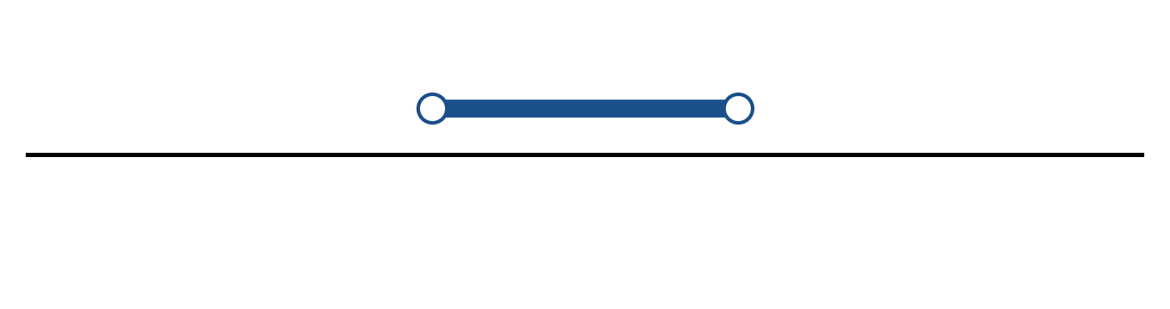
Figure: solution on a number line.
b) Solve the inequality |5x + 3| ≥ 4. Express the answer in interval notation and on a number line.
(5 marks)
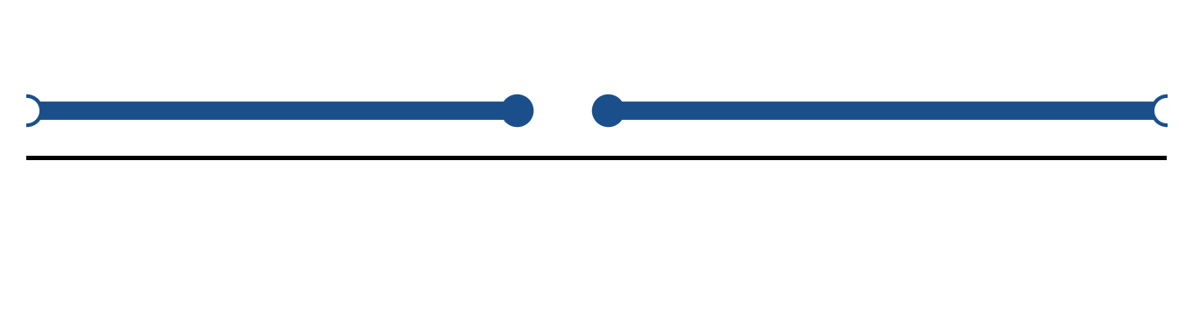
Figure: solution on a number line.
c) Solve the equation |2x + 1| = 6.
(4 marks)
QUESTION 2
a) Given f(x) = (x - 3)/(x - 1) and g(x) = √(4x + 6), state the domain of each function.
(4 marks)
b) Given f(x) = (2 - 5x)/(3x - 4), x ≠ 4/3, find f⁻¹(x) and state its domain.
(5 marks)
c) Sketch the circle x² - 4x + y² + 2y - 11 = 0. State its centre and radius.
(4 marks)
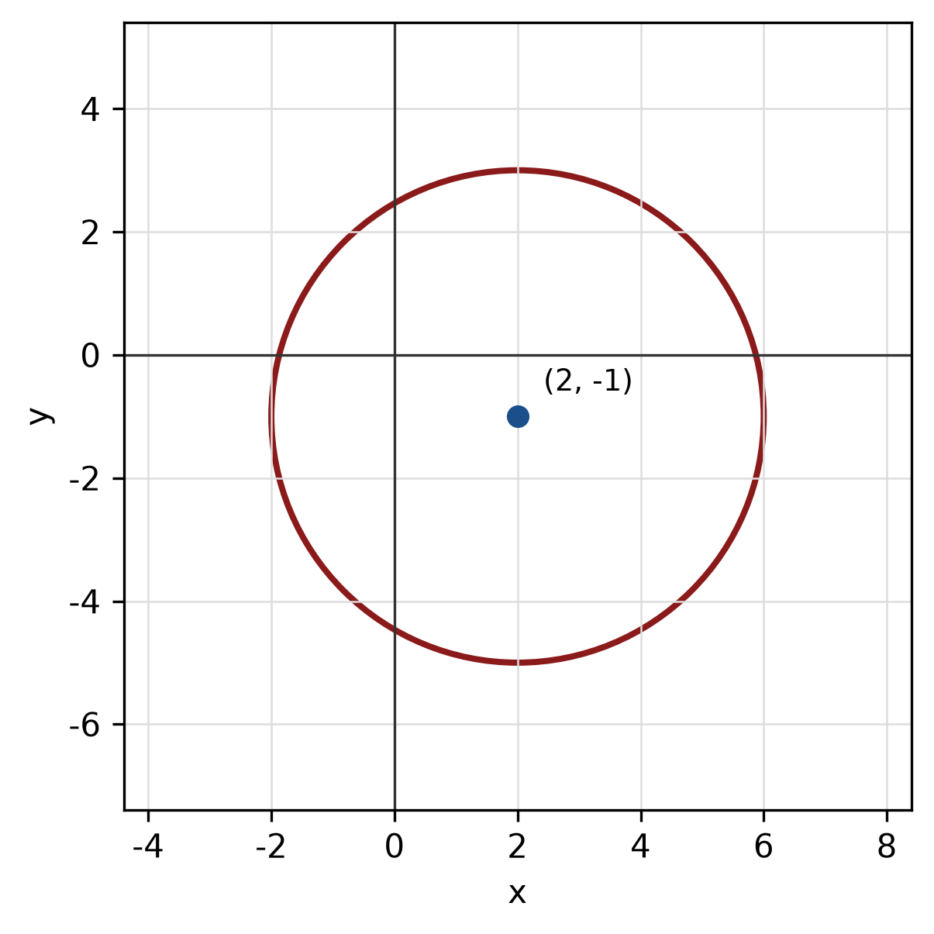
Figure: circle.
QUESTION 3
a) Given z₁ = -5 - 2i and z₂ = 4 - i, find z₁ + z₂ in the form a + bi.
(4 marks)
b) Evaluate i^6 and simplify completely.
(3 marks)
c) Express log_5(5) + log_5(5) as a single logarithm and evaluate it.
(3 marks)
QUESTION 4
a) Graph the system of inequalities below and shade the feasible region. State the vertices of the region.
x ≥ 0, y ≥ 0, 2x + 1y ≤ 8.
(5 marks)
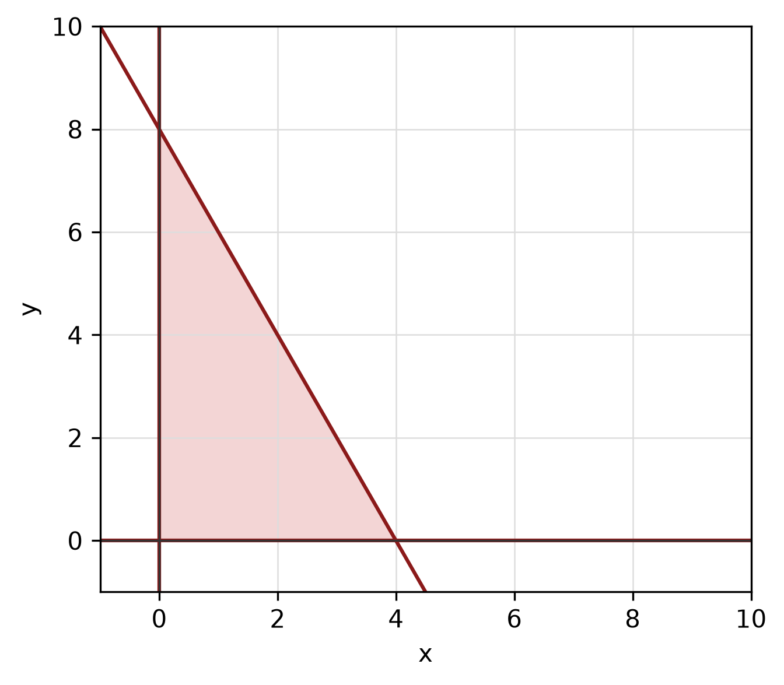
Figure: feasible region.
b) Solve the simultaneous equations
y = x² - 3
y = 1.
(5 marks)
c) Find the equation of the line passing through (2, 1) and parallel to the line 3x - 2y - 4 = 0.
(5 marks)
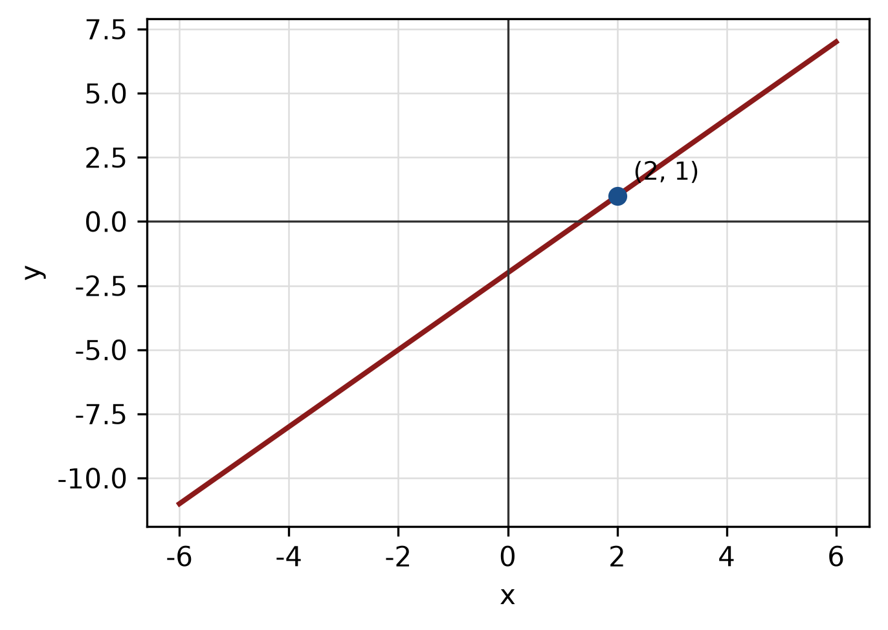
Figure: required line.
QUESTION 5
a) Prove the identity (1 - cos² x)/(sin x cos x) = tan x.
(5 marks)
b) Convert 180° to radians, and convert π/4 radians to degrees.
(3 marks)
c) Solve the triangle with sides a = 14 cm, b = 48 cm and c = 50 cm. Find all three angles.
(5 marks)
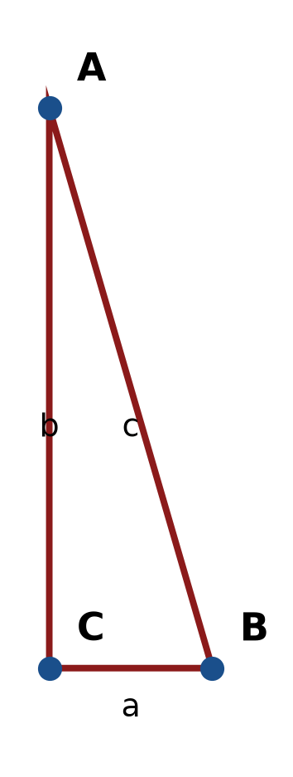
Figure: right triangle.
END OF QUESTION PAPER

APPENDIX 1
Formula sheet (as supplied with the paper).
sin² A + cos² A = 1 | tan² A + 1 = sec² A
sin(A + B) = sin A cos B + cos A sin B | tan 2A = 2 tan A / (1 − tan² A)
cos(A + B) = cos A cos B − sin A sin B | Arc length, s = rθ
tan(A − B) = (tan A − tan B) / (1 + tan A tan B) | Area of sector = ½r²θ
cos 2A = cos² A − sin² A | a / sin A = b / sin B = c / sin C
cos 2A = 1 − 2sin² A = 2cos² A − 1 | a² = b² + c² − 2bc cos A
sin 2A = 2 sin A cos A | Area of triangle = ½ab sin C

